
SPRING 2024
COURSE CODE: CSE421
COURSE TITLE: Computer Networks

LAB - 02(NS3)

PREPARED BY
Name: Nur-E-Jannat
ID: 21301744
Section: 14
Email: nur.e.jannat@g.bracu.ac.bd

1.
Datasize: 128
Throughput: 69.33333333333333
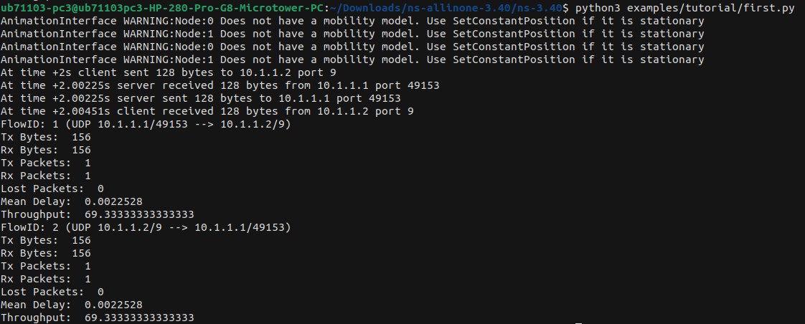

2.
Datasize: 256
Throughput: 126.22222222222223
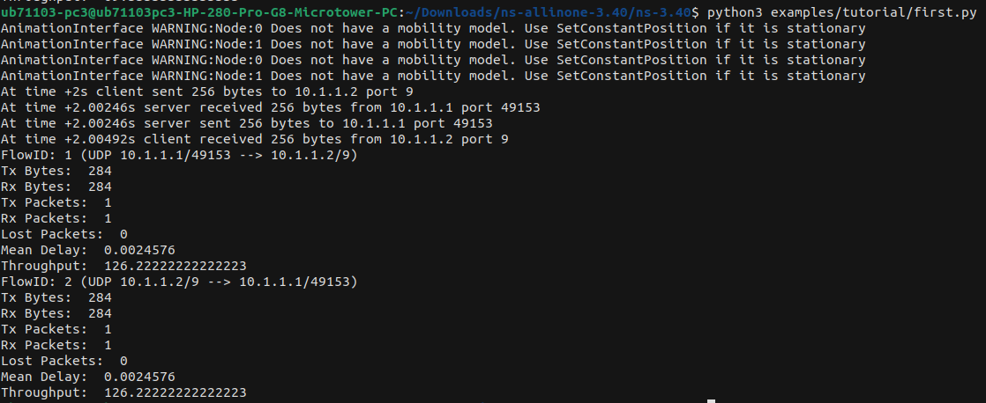

3.
Datasize: 512
Throughput: 240.0
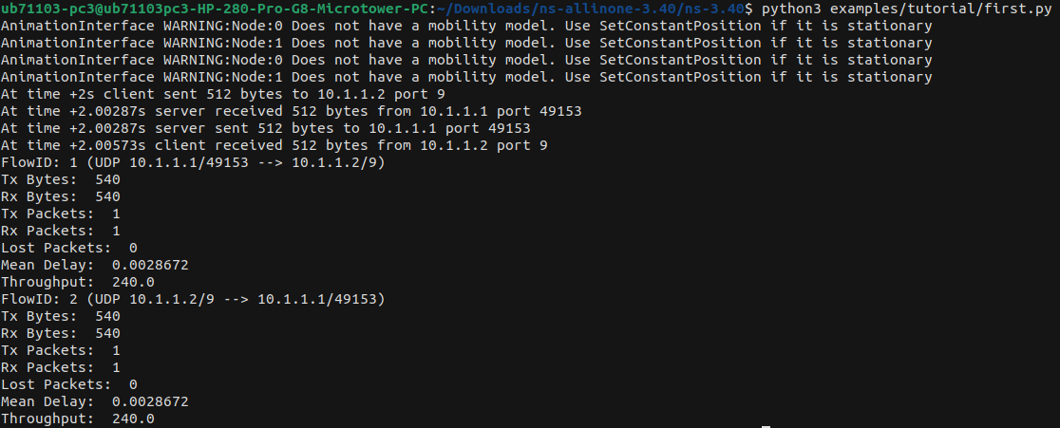

4.
Datasize: 1024
Throughput: 467.55555555555554
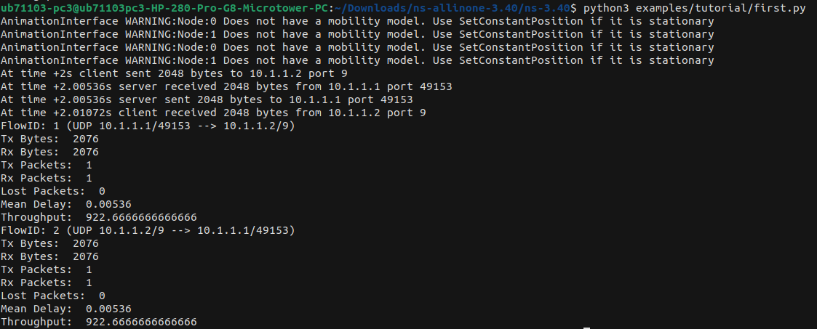

5.
Datasize: 2048
Throughput: 922.6666666666666
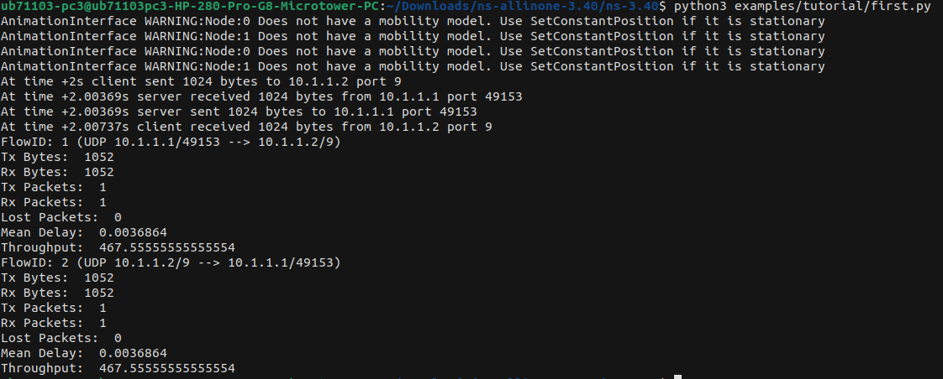

6. Graph Packet size(x-axis) vs Throughput(y-axis)
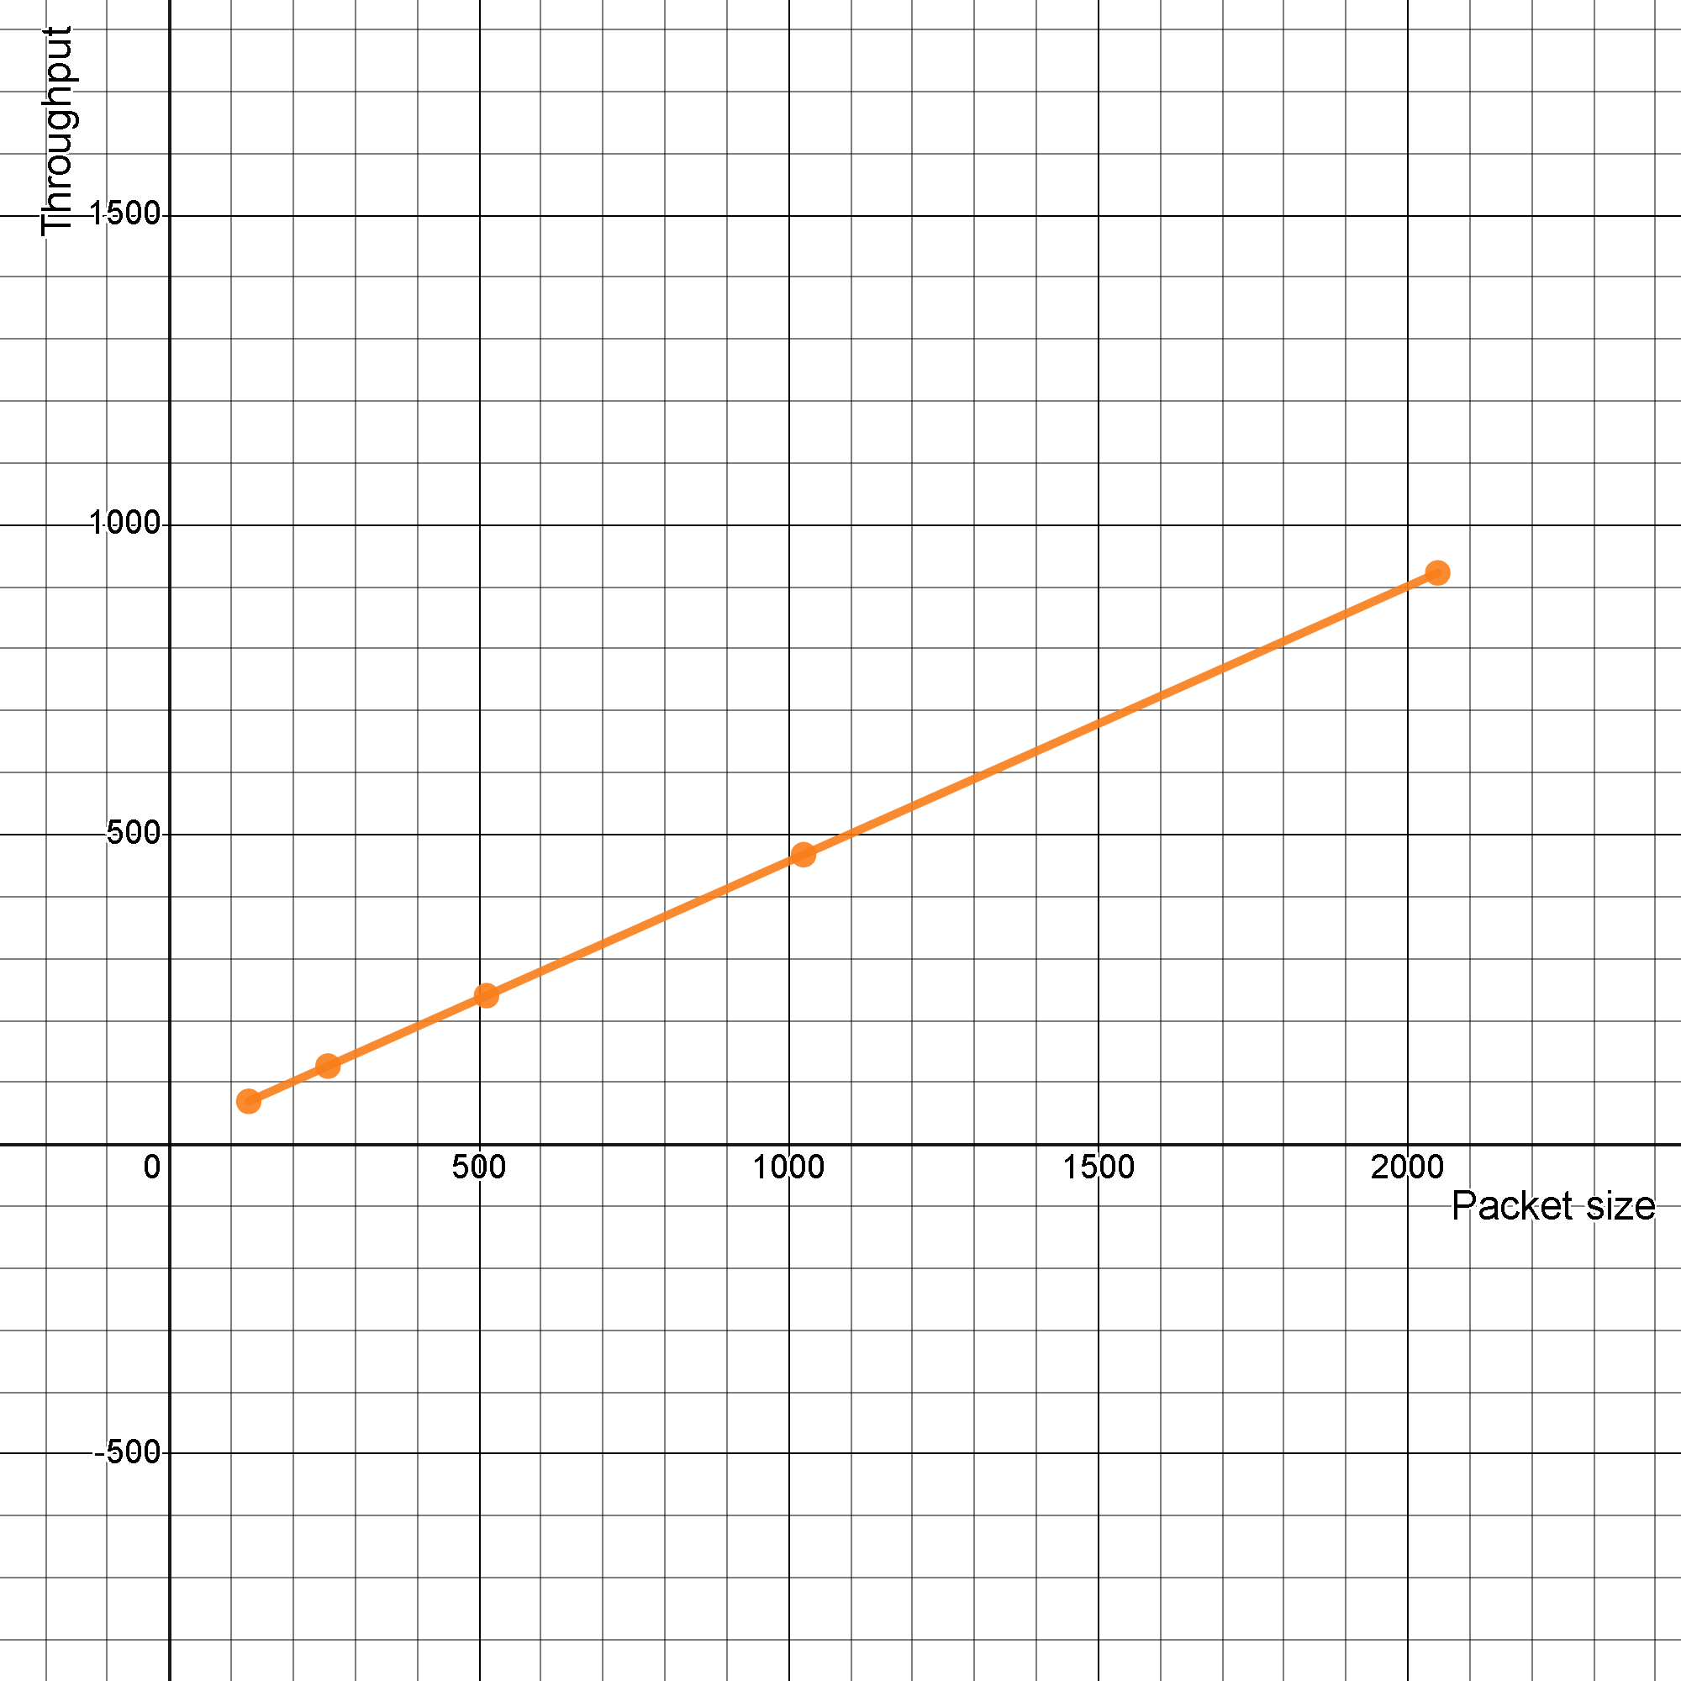

The graph depicts the relationship between packet size and throughput. Packet size, measured in bytes, is represented on the x-axis, while throughput, typically measured in Mbps (megabits per second), is represented on the y-axis. The plotted points suggest a near-linear relationship between packet size and throughput, indicating consistent improvement in throughput with increasing packet size. This relationship is crucial for optimizing network performance and resource utilization, particularly in scenarios where data transfer efficiency is a priority.

